Carlisle United FC,
Brunton Park,
Warwick Road,
Carlisle,
Cumbria,
CA1 1LL
Tel: 01228 526237
Fax: 01228 554141
E-Mail: enquiries@carlisleunited.co.uk
Ticket Office: 0844 371 1921
Blues Store: 01228 554138
Capacity: 17,949
Ground Built: 1909
Record Attendance: 27,500 v Birmingham City, FA Cup 3rd Round, 5th January 1957 and v Middlesbrough FA Cup 5th Round, 7th February 1970
Record Receipts: £146,000 v Tottenham Hotspur, Coca-Cola Cup, 2nd Round, 30th September 1997
Pitch Measurements: 112yds x 74yds
Ownership: CUFC Holdings Ltd owns 94% of Carlisle United AFC (1921) Ltd - Mr HA Jenkins 37.32%; CUOSC 25.37%; Mr JL Nixon 18.66%; Mr S Pattison 18.66%

STADIUM PLAN
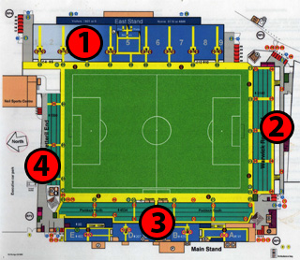
1 – The Pioneer Foods Stand
2 - Warwick Road End
3 - Main Stand and Paddock
4 - Waterworks End

Home Fans
Home fans can choose between seating areas and traditional terracing areas (details below) - all areas provide an unrestricted view of the action.
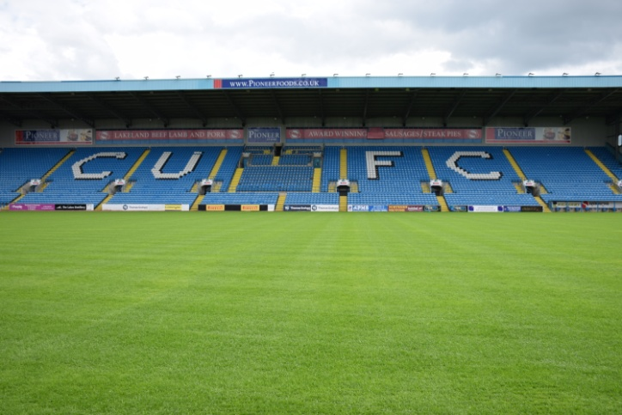
The Pioneer Foods Stand is on the East side of the ground. It is a large, relatively new all-seated area with a concourse underneath that houses bars and food outlets. The North End of the stand (blocks 2 and 3) usually houses away fans and an area of seats is cordoned off to provide segregation. The press are housed at the back of this stand.
This stand also has our Family Zone which opens at 1.30pm for Saturday fixtures and 6.30pm for evening fixtures. Accessed via the main concourse in the Pioneer Foods stand, the Family Zone has games consoles, football play areas, a Wii Console, TV screens, an arts and crafts zone and a superb new sensory area. Please note – section 7 of the Pioneer Foods stand is the preferred seated area for users of our Family Zone, but families and children from any area of the stand can use our Family Zone facility.
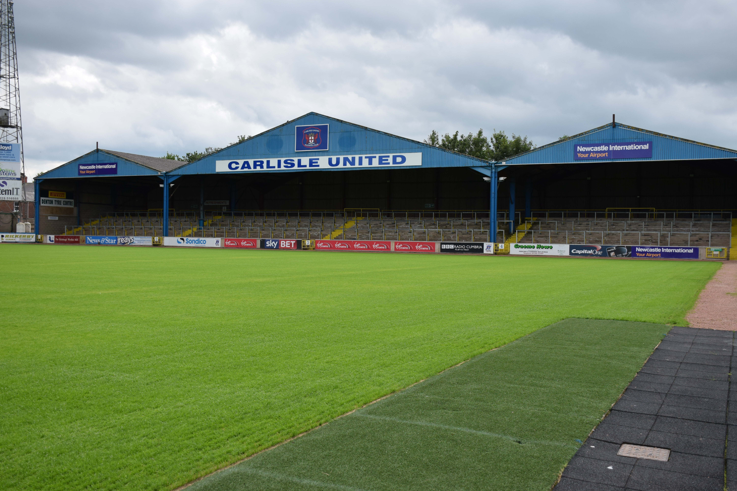
The Warwick Road End is a traditional terraced stand with a distinctive arched roof. This also houses a bar (open for selected matches only) and a food outlet. This area, behind the goal, often generates more noise than any other part of the ground. A place for vocal supporters to get behind their team.
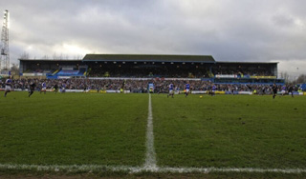
The West side of the ground has a two tiered stand. The bottom tier is known as The Paddock and is a standing terrace. This houses bars on the North and South ends and also food outlets.
The main stand (upper tier) is divided into smaller all-seated areas. From the Warwick Road End of the ground the nearest stand is Cumberland Community A Stand where children from local schools attending the game on our Community Ticket Scheme are situated. There is a toilet block at the entrance to the stairs.
The middle part of the upper tier is divided into B, C, and D (Pirelli) stands. The directors box runs along the front of C Stand.
The area of the upper tier nearest the Petteril End is known as E stand, or more usually the Edinburgh Woollen Mill Stand. This stand is directly above Foxy's Restaurant and the corporate boxes. There are bars available throughout the main stand and food outlets outside the stand.
Away Fans
The North End (Blocks 2 and 3) of the Pioneer Foods Stand on the east side of the ground houses the away fans. The concourse underneath houses a bar and food outlet. Should additional space be required for away fans then the open terracing at the Petteril End of the ground is opened which includes a food outlet. This also includes very limited seating.
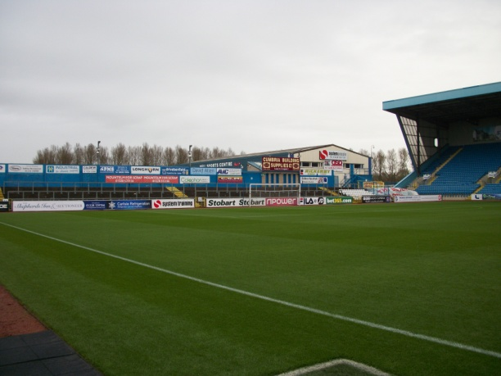
Please note – all areas of the ground are family friendly. If any supporters experience any bad language in any area of the ground this can be reported to the club by texting the match day safety number which is 07837 097977 with the stand, row and seat number (if applicable) with full details of the incident.
For prices and how to book your tickets go to http://www.carlisleunited.co.uk/tickets/ticket-prices/.

How To Get Here
By Road - Brunton Park is within easy reach of the M6.
Leave the motorway at Junction 43 and take the first exit off the roundabout. The blue roof of the Pioneer Foods Stand can be seen on the right hand side, almost as soon as you leave the roundabout.
Keep going straight ahead along Warwick Road (A69).
After passing through the third set of traffic lights the club shop (Blues Store) and Hughie McIlmoyle statue marks the main entrance to the ground.
Car parking in this area is strictly limited to pass holders, visiting directors (by prior arrangement) and the away team bus. Please note – the car park on the West side of the ground is closed approximately fifteen minutes before kick-off when crowd congestion is at its worst.
Car Parking
Cars: Main Car Park (home and away supporters) - From the M6 turn right at the 3rd set of traffic lights and drive through the gates and behind the Pioneer Foods Stand to enter the car park. Supporters travelling from the West can enter the car park from St Aidans Road via Victoria Place. Due to the location of our car park, we advise fans to check the availability of car parking facilities when the weather is bad. Cars are charged £3 to use the car park. Please note – cars will only be allowed the exit the car park after the game once all supporters have cleared the area and any away coaches have left the stadium
Disabled car parking: There is limited disabled car parking available at the North end of the Pioneer Foods Stand – this is only available to blue badge holders and is free.
Coaches other than the Official team coach: From Junction 43 take the first exit off the roundabout. At the third set of traffic lights turn right. Stewards will allow the bus through behind the Pioneer Foods Stand for passengers to disembark at the away turnstiles; the bus will then be directed to the car park and allowed back after the game to pick up passengers from the away end. All coaches, other than the official team coach, are charged £15 with minibuses being charged £10.
By Rail - Carlisle Citadel Station is served by the West Coast Main line, with the station situated in the middle of Carlisle. From the station, walk straight ahead across Botchergate and walk along the Crescent until you see the entrance to Warwick Road on the right, next to Nandos. Brunton Park is about a twenty minute walk from the entrance to Warwick Road.

Disabled Facilities
Home fans who are wheelchair users are allocated places at the North end of the Paddock or in front of the Pioneer Foods Stand. Away wheelchair supporters are situated in the Waterworks end however if the weather is poor they are placed in an area below the away fans to provide some shelter from the elements. Tickets for wheelchair users are priced £4 with the maximum of one carer free. Tickets can be bought in advance from main reception or, on match days, from either the Paddock ticket office or the Pioneer Foods Stand ticket office. Please note – wheelchair spaces are limited and are sold on a first come, first served basis.
Supporters with visual difficulties may wish to bring a portable radio as full match commentary is available from BBC Radio Cumbria on 95.6 FM and 756 AM frequencies.
Visitors requiring further information should ring main reception on (01228) 526 237.
Emergency Procedures
In the event of an emergency occurring at the stadium, the Public Address System will be used to broadcast information and directions to spectators. Such broadcasts will be preceded by a three-tone chime. When the chimes are heard, please be silent, pay attention to what is said and obey any instructions. An example of this alert will be carried out just before kick-off and at half-time, and will be clearly stated that the announcement is for instructive purpose only.

